Experiment / Case Study No.: 7
EXPERIMENT
1. Experiment Title:
Perform DOM traversal and updates; develop a to-do list app with add, edit, and delete features.
2. Software/Tools Required:
VS Code (text editor), HTML, CSS, JavaScript.
3. Experiment Program Code:
Task Manager — Drag & Drop To-Do Board (index.html + style.css + script.js) –
index.html:
<!DOCTYPE html>
<html lang="en">
<head>
<meta charset="UTF-8">
<meta name="viewport" content="width=device-width, initial-scale=1.0">
<title>Task Manager</title>
<link rel="stylesheet" href="style.css">
</head>
<body>
<div class="container">
<header class="header">
<div>
<h1>Task Manager</h1>
<p>Organize your work and stay productive.</p>
</div>
<button id="addTaskBtn">+ Add Task</button>
</header>

<div class="task-form" id="taskForm">
<input type="text" id="taskInput" placeholder="Enter a task...">
<button id="saveTaskBtn">Add Task</button>
<button id="cancelTaskBtn" class="cancel-btn">Cancel</button>
</div>

<main class="board">
<section class="column">
<div class="column-header">
<h2>To Do</h2>
<span id="todoCount">0</span>
</div>
<div class="task-list" id="todo" data-status="todo"></div>
</section>

<section class="column">
<div class="column-header">
<h2>In Progress</h2>
<span id="progressCount">0</span>
</div>
<div class="task-list" id="inprogress" data-status="inprogress"></div>
</section>

<section class="column">
<div class="column-header">
<h2>Done</h2>
<span id="doneCount">0</span>
</div>
<div class="task-list" id="done" data-status="done"></div>
</section>
</main>

<footer>Designed by: Ritisha Naigaonkar, 24070521045, A2</footer>
</div>
<script src="script.js"></script>
</body>
</html>

style.css:
* {
margin: 0;
padding: 0;
box-sizing: border-box;
}

body {
font-family: Arial, sans-serif;
min-height: 100vh;
background: #f5f4f8;
color: #333;
padding: 40px 25px;
}

.container {
max-width: 1200px;
margin: auto;
}

.header {
display: flex;
justify-content: space-between;
align-items: center;
margin-bottom: 30px;
}

.header h1 {
color: #514477;
font-size: 30px;
margin-bottom: 6px;
}

.header p {
color: #888;
font-size: 14px;
}

#addTaskBtn {
background: #66558f;
color: white;
border: none;
padding: 12px 20px;
border-radius: 8px;
font-size: 14px;
font-weight: bold;
cursor: pointer;
transition: 0.2s;
}

#addTaskBtn:hover {
background: #514477;
}

.task-form {
display: none;
background: white;
padding: 15px;
border-radius: 10px;
margin-bottom: 25px;
box-shadow: 0 5px 20px rgba(0,0,0,0.07);
}

.task-form.show {
display: flex;
gap: 10px;
}

#taskInput {
flex: 1;
padding: 11px 13px;
border: 1px solid #ddd;
border-radius: 7px;
outline: none;
font-size: 14px;
}

#taskInput:focus {
border-color: #66558f;
box-shadow: 0 0 0 3px rgba(102,85,143,0.1);
}

#saveTaskBtn {
background: #66558f;
color: white;
border: none;
padding: 10px 18px;
border-radius: 7px;
cursor: pointer;
font-weight: bold;
}

.cancel-btn {
background: #eee;
color: #555;
border: none;
padding: 10px 15px;
border-radius: 7px;
cursor: pointer;
}

.board {
display: grid;
grid-template-columns: repeat(3,1fr);
gap: 20px;
align-items: start;
}

.column {
background: #ebe9f0;
border-radius: 12px;
padding: 16px;
min-height: 450px;
}

.column-header {
display: flex;
justify-content: space-between;
align-items: center;
margin-bottom: 15px;
}

.column-header h2 {
font-size: 16px;
color: #514477;
}

.column-header span {
background: white;
color: #66558f;
min-width: 25px;
height: 25px;
border-radius: 50%;
display: flex;
justify-content: center;
align-items: center;
font-size: 12px;
font-weight: bold;
}

.task-list {
min-height: 380px;
}

.task {
background: white;
padding: 15px;
border-radius: 9px;
margin-bottom: 12px;
box-shadow: 0 3px 10px rgba(0,0,0,0.06);
cursor: grab;
position: relative;
transition: 0.2s;
}

.task:hover {
transform: translateY(-2px);
box-shadow: 0 6px 15px rgba(0,0,0,0.09);
}

.task:active {
cursor: grabbing;
}

.task.dragging {
opacity: 0.5;
}

.task p {
font-size: 14px;
line-height: 1.5;
padding-right: 25px;
}

.delete-btn {
position: absolute;
top: 10px;
right: 10px;
border: none;
background: transparent;
color: #aaa;
font-size: 17px;
cursor: pointer;
}

.delete-btn:hover {
color: #d9534f;
}

.task-list.drag-over {
background: rgba(102,85,143,0.08);
border-radius: 8px;
}

footer {
text-align: center;
margin-top: 35px;
color: #888;
font-size: 13px;
}

@media (max-width: 800px) {
.board {
grid-template-columns: 1fr;
}

.column {
min-height: 300px;
}

.task-list {
min-height: 150px;
}
}

@media (max-width: 550px) {
body {
padding: 25px 15px;
}

.header {
align-items: flex-start;
gap: 15px;
flex-direction: column;
}

.task-form.show {
flex-direction: column;
}

#saveTaskBtn,
.cancel-btn {
width: 100%;
}
}

script.js:
// ==========================================
// ACCESSING ELEMENTS
// ==========================================

const addTaskBtn = document.getElementById("addTaskBtn");
const taskForm = document.getElementById("taskForm");
const taskInput = document.getElementById("taskInput");
const saveTaskBtn = document.getElementById("saveTaskBtn");
const cancelTaskBtn = document.getElementById("cancelTaskBtn");
const taskLists = document.querySelectorAll(".task-list");

// ==========================================
// ADD TASK BUTTON
// ==========================================

addTaskBtn.addEventListener("click", function() {
taskForm.classList.add("show");
taskInput.focus();
});

// ==========================================
// CANCEL BUTTON
// ==========================================

cancelTaskBtn.addEventListener("click", function() {
taskForm.classList.remove("show");
taskInput.value = "";
});

// ==========================================
// ADD TASK
// ==========================================

saveTaskBtn.addEventListener("click", function() {
const taskText = taskInput.value.trim();

if (taskText === "") {
alert("Please enter a task.");
return;
}

createTask(taskText);

taskInput.value = "";
taskForm.classList.remove("show");
});

// ==========================================
// ENTER KEY
// ==========================================

taskInput.addEventListener("keydown", function(event) {
if (event.key === "Enter") {
saveTaskBtn.click();
}
});

// ==========================================
// CREATE TASK
// ==========================================

function createTask(text) {
const task = document.createElement("div");
task.classList.add("task");
task.draggable = true;

const paragraph = document.createElement("p");
paragraph.textContent = text;

const deleteButton = document.createElement("button");
deleteButton.classList.add("delete-btn");
deleteButton.textContent = "×";

// DELETE TASK
deleteButton.addEventListener("click", function() {
task.remove();
updateCounts();
});

task.appendChild(paragraph);
task.appendChild(deleteButton);

document.getElementById("todo").appendChild(task);

addDragEvents(task);
updateCounts();
}

// ==========================================
// DRAG EVENTS
// ==========================================

function addDragEvents(task) {

// DRAG START
task.addEventListener("dragstart", function() {
task.classList.add("dragging");
});

// DRAG END
task.addEventListener("dragend", function() {
task.classList.remove("dragging");
updateCounts();
});
}

// ==========================================
// DROP EVENTS
// ==========================================

taskLists.forEach(function(list) {

// DRAG OVER
list.addEventListener("dragover", function(event) {
event.preventDefault();
list.classList.add("drag-over");
});

// DRAG LEAVE
list.addEventListener("dragleave", function() {
list.classList.remove("drag-over");
});

// DROP
list.addEventListener("drop", function(event) {
event.preventDefault();

const draggingTask = document.querySelector(".dragging");

if (draggingTask) {
list.appendChild(draggingTask);
}

list.classList.remove("drag-over");
updateCounts();
});
});

// ==========================================
// UPDATE COUNTS
// ==========================================

function updateCounts() {
const todoTasks = document.querySelectorAll("#todo .task");
const progressTasks = document.querySelectorAll("#inprogress .task");
const doneTasks = document.querySelectorAll("#done .task");

document.getElementById("todoCount").textContent = todoTasks.length;
document.getElementById("progressCount").textContent = progressTasks.length;
document.getElementById("doneCount").textContent = doneTasks.length;
}

4. Output:
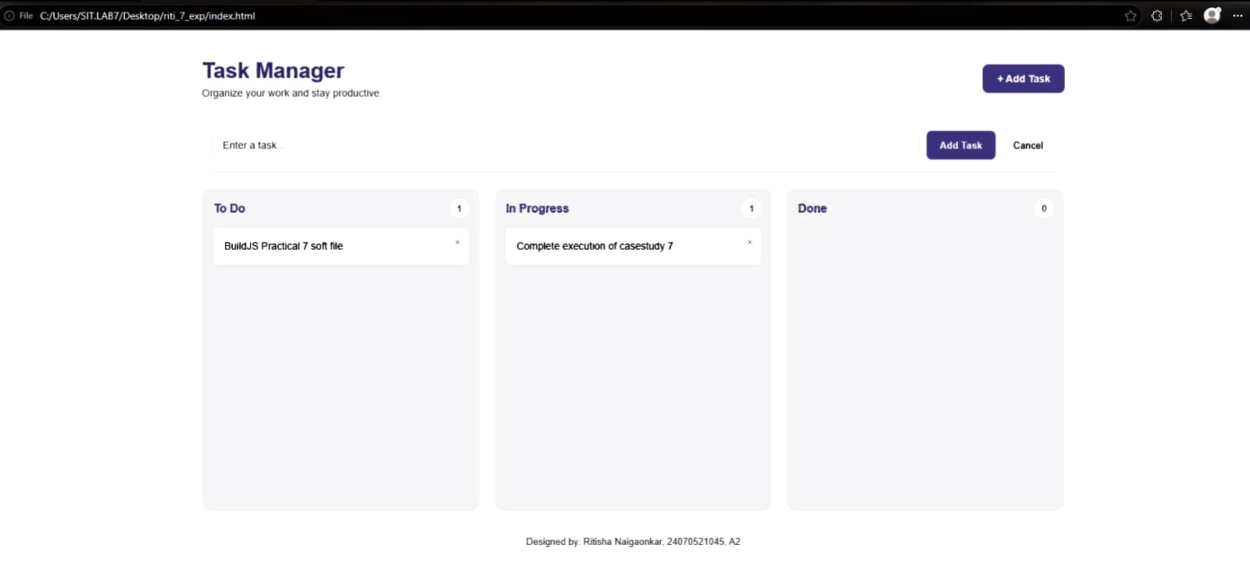
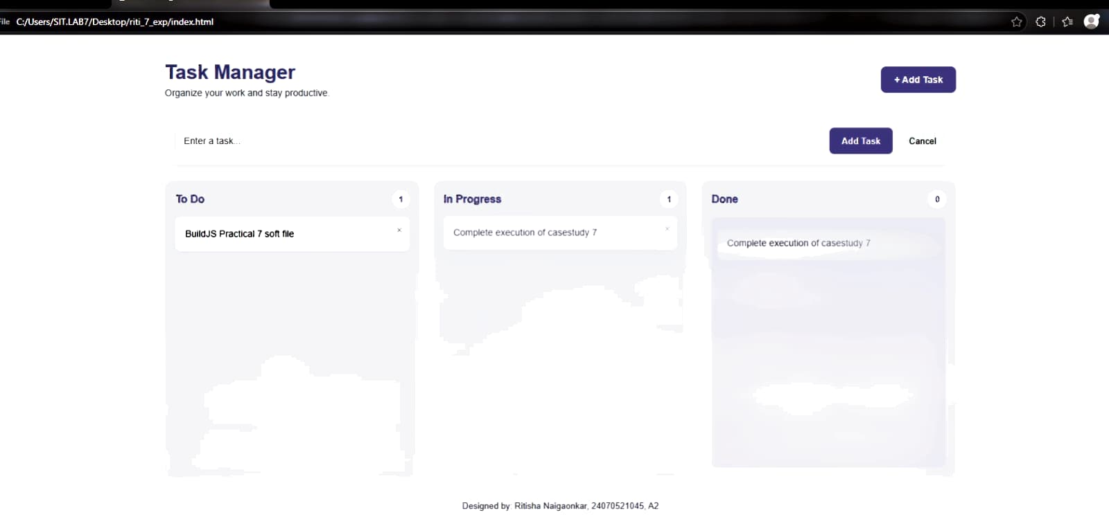
CASE STUDY
5. Case Study Title:
To demonstrate event handling in JavaScript by creating a registration form, accessing and manipulating form elements, validating user inputs, and handling events such as submit, change, and focus.
6. Case Study Program Code:
Registration Form — Event Handling & Validation (index.html + style.css + script.js) –
index.html:
<!DOCTYPE html>
<html lang="en">
<head>
<meta charset="UTF-8">
<meta name="viewport" content="width=device-width, initial-scale=1.0">
<title>Task Manager</title>
<link rel="stylesheet" href="style.css">
</head>
<body>

<div class="reg-wrapper">
<form class="reg-card" id="regForm" novalidate>
<h1>Registration Form</h1>
<p class="subtitle">Create your account by filling in the details below.</p>
<p class="mandatory-note">* Mandatory to fill</p>

<div class="field">
<label for="firstName">First Name <span class="req">*</span></label>
<input type="text" id="firstName" placeholder="Enter first name">
<span class="error" id="firstNameError"></span>
</div>

<div class="field">
<label for="lastName">Last Name</label>
<input type="text" id="lastName" placeholder="Enter last name">
</div>

<div class="field">
<label>Birthday</label>
<div class="birthday-row">
<select id="day"></select>
<select id="month"></select>
<select id="year"></select>
</div>
</div>

<div class="field">
<label for="username">Username <span class="req">*</span></label>
<input type="text" id="username" placeholder="Choose a username">
<span class="error" id="usernameError"></span>
</div>

<div class="field">
<label for="email">E-mail <span class="req">*</span></label>
<input type="text" id="email" placeholder="example@email.com">
<span class="error" id="emailError"></span>
</div>

<div class="field">
<label for="website">Website</label>
<input type="text" id="website" placeholder="https://example.com">
</div>

<div class="field">
<label for="password">Password <span class="req">*</span></label>
<input type="password" id="password" placeholder="Enter password">
<span class="error" id="passwordError"></span>
</div>

<div class="field">
<label for="rePassword">Re-password <span class="req">*</span></label>
<input type="password" id="rePassword" placeholder="Confirm password">
<span class="error" id="rePasswordError"></span>
</div>

<div class="checkbox-row">
<input type="checkbox" id="terms">
<label for="terms">I agree to the <a href="#">Terms &amp; Conditions</a>.</label>
</div>
<span class="error" id="termsError"></span>

<button type="submit" id="signUpBtn">Sign Up</button>
<p class="success-msg" id="successMsg"></p>
</form>
</div>

<footer>Designed by: Ritisha Naigaonkar, 24070521045, A2</footer>

<script src="script.js"></script>
</body>
</html>

style.css:
* {
margin: 0;
padding: 0;
box-sizing: border-box;
}

body {
font-family: Arial, sans-serif;
min-height: 100vh;
background: #f5f4f8;
color: #333;
padding: 40px 25px 20px;
}

.reg-wrapper {
display: flex;
justify-content: center;
}

.reg-card {
background: white;
width: 100%;
max-width: 460px;
padding: 30px 34px 34px;
border-radius: 14px;
box-shadow: 0 10px 30px rgba(0,0,0,0.08);
}

.reg-card h1 {
text-align: center;
color: #514477;
font-size: 24px;
margin-bottom: 6px;
}

.subtitle {
text-align: center;
color: #888;
font-size: 13px;
margin-bottom: 14px;
}

.mandatory-note {
color: #d9534f;
font-size: 11px;
margin-bottom: 16px;
}

.field {
margin-bottom: 16px;
}

.field label,
.birthday-row + label,
label {
display: block;
font-size: 13px;
font-weight: bold;
color: #333;
margin-bottom: 6px;
}

.req {
color: #d9534f;
}

input[type="text"],
input[type="password"],
input[type="email"] {
width: 100%;
padding: 10px 12px;
border: 1px solid #ddd;
border-radius: 7px;
font-size: 13px;
outline: none;
transition: 0.2s;
}

input[type="text"]:focus,
input[type="password"]:focus {
border-color: #66558f;
box-shadow: 0 0 0 3px rgba(102,85,143,0.1);
}

.birthday-row {
display: flex;
gap: 10px;
}

.birthday-row select {
flex: 1;
padding: 10px 8px;
border: 1px solid #ddd;
border-radius: 7px;
font-size: 13px;
background: white;
color: #333;
}

.error {
display: block;
color: #d9534f;
font-size: 11.5px;
margin-top: 5px;
min-height: 14px;
}

.checkbox-row {
display: flex;
align-items: flex-start;
gap: 8px;
margin-bottom: 4px;
font-size: 12.5px;
color: #333;
}

.checkbox-row input[type="checkbox"] {
margin-top: 2px;
}

.checkbox-row a {
color: #66558f;
font-weight: bold;
text-decoration: none;
}

.checkbox-row a:hover {
text-decoration: underline;
}

#signUpBtn {
width: 100%;
background: #514477;
color: white;
border: none;
padding: 13px;
border-radius: 8px;
font-size: 14px;
font-weight: bold;
cursor: pointer;
margin-top: 14px;
transition: 0.2s;
}

#signUpBtn:hover {
background: #423861;
}

.success-msg {
text-align: center;
color: #3b8e5a;
font-size: 13px;
font-weight: bold;
margin-top: 12px;
min-height: 16px;
}

footer {
text-align: center;
margin-top: 25px;
color: #888;
font-size: 13px;
}

@media (max-width: 500px) {
.reg-card {
padding: 24px 20px 28px;
}

.birthday-row {
flex-direction: column;
}
}

script.js:
// ==========================================
// ACCESSING FORM ELEMENTS (DOM traversal)
// ==========================================

const regForm = document.getElementById("regForm");

const firstNameInput = document.getElementById("firstName");
const usernameInput = document.getElementById("username");
const emailInput = document.getElementById("email");
const passwordInput = document.getElementById("password");
const rePasswordInput = document.getElementById("rePassword");
const termsCheckbox = document.getElementById("terms");
const successMsg = document.getElementById("successMsg");

const daySelect = document.getElementById("day");
const monthSelect = document.getElementById("month");
const yearSelect = document.getElementById("year");

// ==========================================
// BUILD THE BIRTHDAY DROPDOWNS DYNAMICALLY
// (DOM manipulation - creating elements)
// ==========================================

function populateBirthday() {

// Day: 1 - 31
const dayPlaceholder = document.createElement("option");
dayPlaceholder.textContent = "Day";
daySelect.appendChild(dayPlaceholder);

for (let d = 1; d <= 31; d++) {
const option = document.createElement("option");
option.value = d;
option.textContent = d;
daySelect.appendChild(option);
}

// Month: Jan - Dec
const months = ["January", "February", "March", "April", "May", "June",
"July", "August", "September", "October", "November", "December"];

const monthPlaceholder = document.createElement("option");
monthPlaceholder.textContent = "Month";
monthSelect.appendChild(monthPlaceholder);

months.forEach(function (monthName) {
const option = document.createElement("option");
option.value = monthName;
option.textContent = monthName;
monthSelect.appendChild(option);
});

// Year: current year down to 100 years ago
const yearPlaceholder = document.createElement("option");
yearPlaceholder.textContent = "Year";
yearSelect.appendChild(yearPlaceholder);

const currentYear = new Date().getFullYear();
for (let y = currentYear; y >= currentYear - 100; y--) {
const option = document.createElement("option");
option.value = y;
option.textContent = y;
yearSelect.appendChild(option);
}
}

populateBirthday();

// ==========================================
// HELPER - SHOW / CLEAR AN ERROR MESSAGE
// ==========================================

function showError(id, message) {
document.getElementById(id).textContent = message;
}

function clearError(id) {
document.getElementById(id).textContent = "";
}

// ==========================================
// FOCUS EVENT - clear a field's error as soon
// as the user comes back to fix it
// ==========================================

firstNameInput.addEventListener("focus", function () {
clearError("firstNameError");
});

usernameInput.addEventListener("focus", function () {
clearError("usernameError");
});

emailInput.addEventListener("focus", function () {
clearError("emailError");
});

passwordInput.addEventListener("focus", function () {
clearError("passwordError");
});

rePasswordInput.addEventListener("focus", function () {
clearError("rePasswordError");
});

// ==========================================
// CHANGE EVENT - validate email as soon as
// the user leaves the field
// ==========================================

emailInput.addEventListener("change", function () {
validateEmail();
});

// ==========================================
// INPUT EVENT - live password match check
// ==========================================

rePasswordInput.addEventListener("input", function () {
validatePasswordMatch();
});

// ==========================================
// VALIDATION FUNCTIONS
// ==========================================

function validateEmail() {
const emailPattern = /^[^\s@]+@[^\s@]+\.[^\s@]+$/;
const value = emailInput.value.trim();

if (value !== "" && !emailPattern.test(value)) {
showError("emailError", "Enter a valid email address.");
return false;
}

clearError("emailError");
return true;
}

function validatePasswordMatch() {
if (rePasswordInput.value !== "" && rePasswordInput.value !== passwordInput.value) {
showError("rePasswordError", "Passwords do not match.");
return false;
}

clearError("rePasswordError");
return true;
}

function validateRequired(input, errorId, message) {
if (input.value.trim() === "") {
showError(errorId, message);
return false;
}
clearError(errorId);
return true;
}

// ==========================================
// SUBMIT EVENT - run every check together
// ==========================================

regForm.addEventListener("submit", function (event) {
event.preventDefault();

let isValid = true;

if (!validateRequired(firstNameInput, "firstNameError", "First name is required.")) {
isValid = false;
}

if (!validateRequired(usernameInput, "usernameError", "Username is required.")) {
isValid = false;
}

if (!validateRequired(emailInput, "emailError", "E-mail is required.")) {
isValid = false;
} else if (!validateEmail()) {
isValid = false;
}

if (!validateRequired(passwordInput, "passwordError", "Password is required.")) {
isValid = false;
}

if (!validateRequired(rePasswordInput, "rePasswordError", "Please confirm your password.")) {
isValid = false;
} else if (!validatePasswordMatch()) {
isValid = false;
}

if (!termsCheckbox.checked) {
showError("termsError", "Please accept the Terms & Conditions.");
isValid = false;
} else {
clearError("termsError");
}

if (!isValid) {
successMsg.textContent = "";
return;
}

// All good - show success and reset the form
successMsg.textContent = "Registration successful!";
regForm.reset();

// Rebuild the birthday dropdowns since reset() clears the injected options' selection
daySelect.selectedIndex = 0;
monthSelect.selectedIndex = 0;
yearSelect.selectedIndex = 0;
});

7. Output:
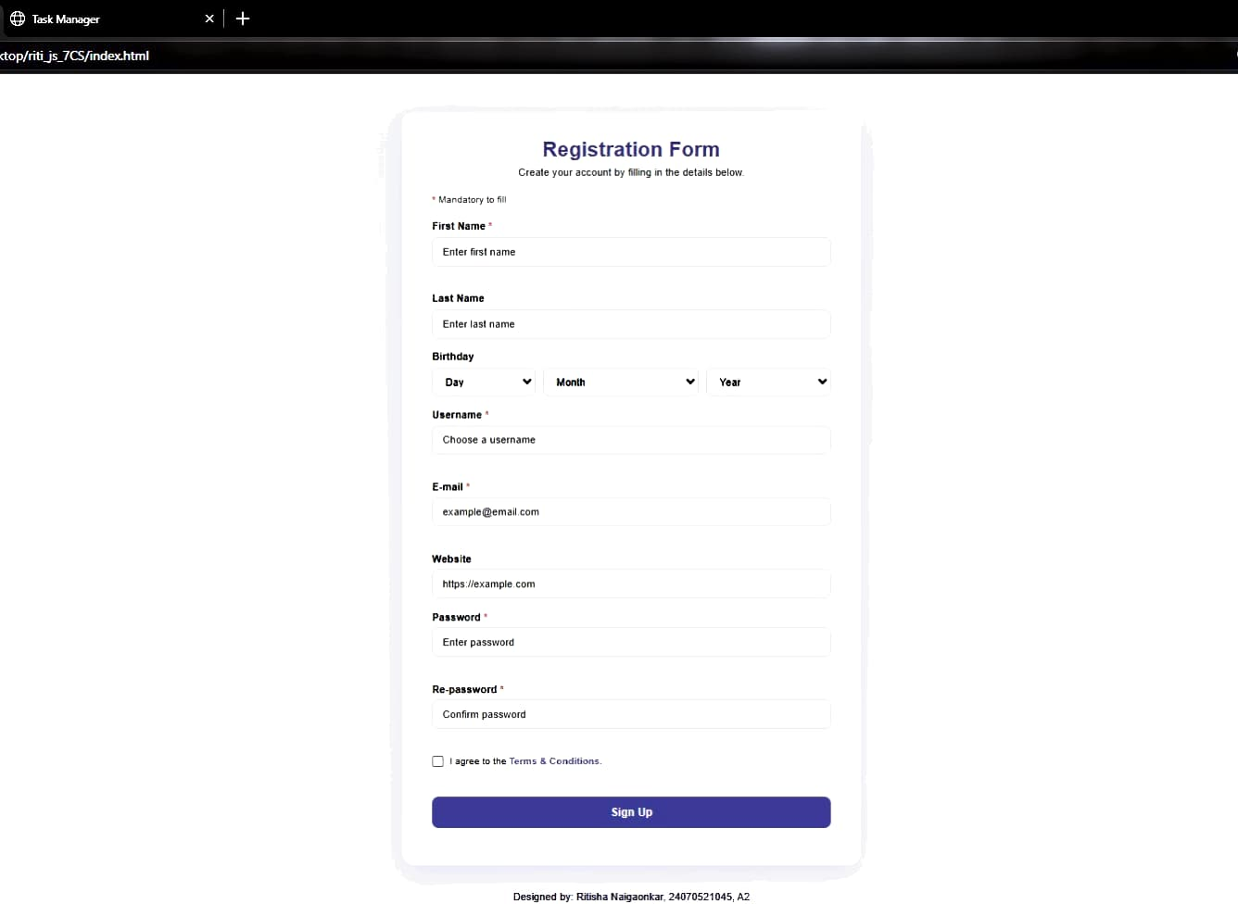
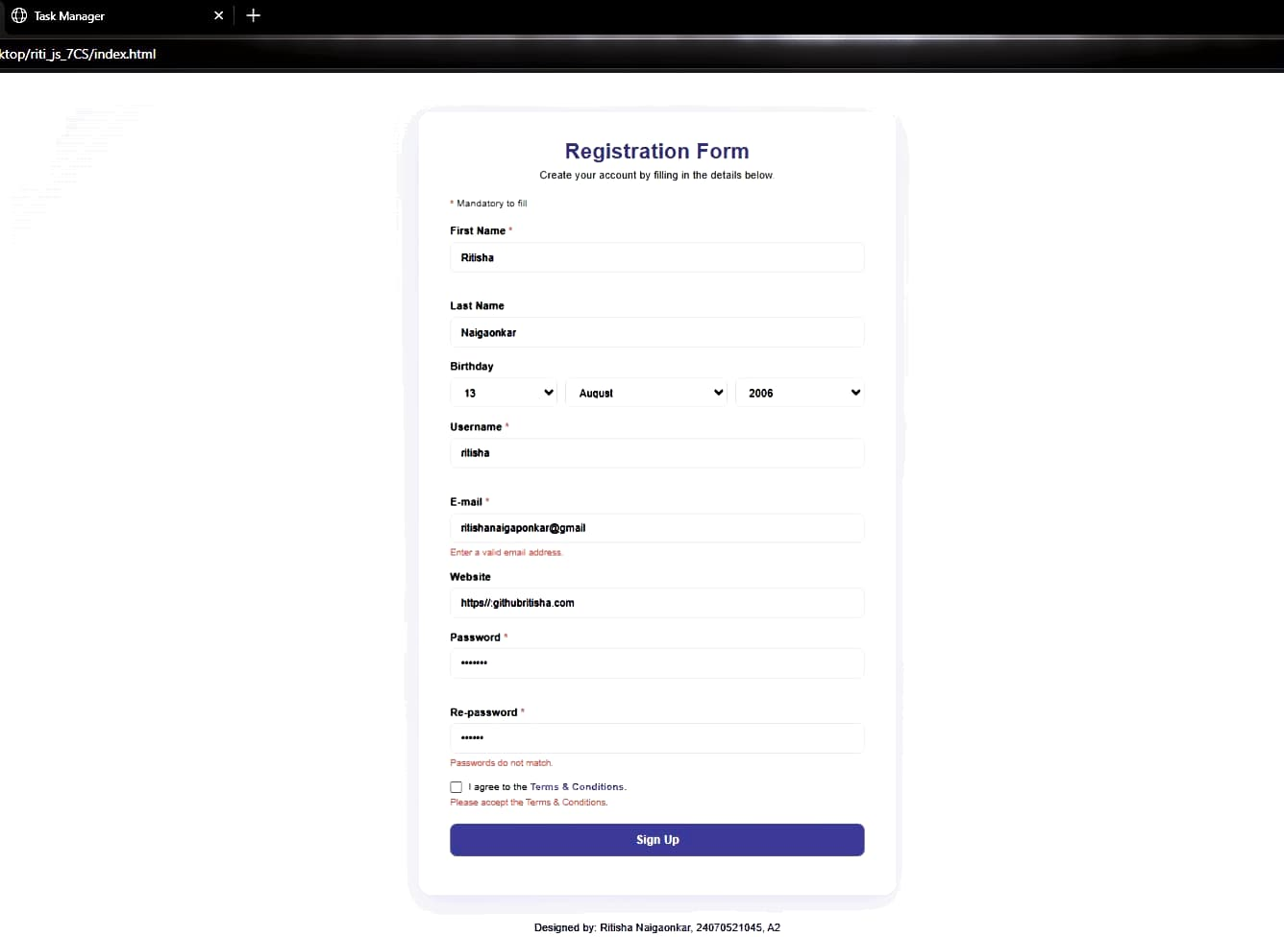
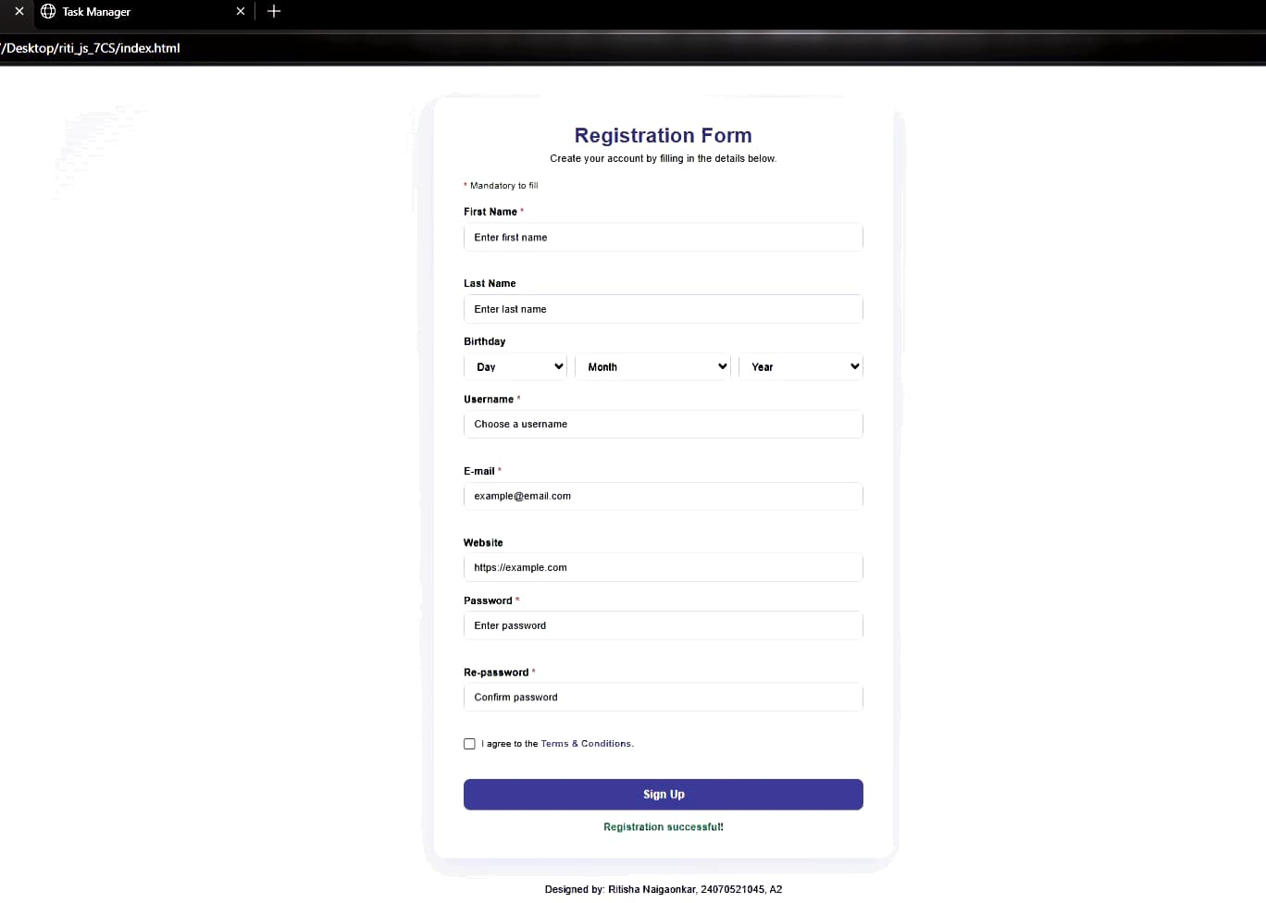
8. Result/Conclusion:
Thus DOM traversal and updates were studied and implemented by developing a To-Do List (Task Manager) application with add, drag-and-drop status update, and delete features. Event handling in JavaScript was also studied and implemented through a Registration Form that accesses and manipulates form elements, validates user inputs, and handles submit, change and focus events, and the desired output was verified.
Ritisha Naigaonkar, 24070521045, V-A(A2)

